Aimee Shoun

Research

Game: Dinosausrs that intelligent. They have been hiding in the planet since the last extinction. There has been a government cover up and the government is fighting the dinosuars trying to make them extint once and for all.

Weapons:

Gun that are upgradable as the characters go through the levels

Characters :

Dinosausrs that intelligent. They have been hiding in the planet since the last extinction. There has been a government cover up and the government is fighting the dinosuars trying to make them extint once and for all.

The game play is very similar to Skylander

The esstiesstic is very similar to ori

The enemies will have stun guns. They collect dinosaurs for experimentation.

The dinosuars use portals for travel

As you go through the game you will gain b

~~Idea 1intelligent dinosaurs in Hollow earth. The goal is to journey thru the levels of the planets while using portals and Digging abilities. You battle the humans of earth using guns to make it to the surface and take over the planet.~~

I was thinking I would do a gender neutral game that is center around dinosaurs living inside the planet in caves. We would just see the bottom of the cave. The enemy are the human beings that live on the surface of the planet. They would use guns and portals for fighting and movement. They will pick up power ups and evolve through the levels. The levels will be somewhat of an obstacle course so that the dinosausrs will make it through the levels of the planet so they can make it to the surface of the planet and take it over.

~~Dinosuars hatch out of eggs…~~

~~They eat mushroom for power ups~~

~~They use crystals for coins~~

~~Use potals and digging for movement~~

~~Use human ai need to combat with guns.~~

~~The gun will get better has they journey thru the game. You will find guns.~~

~~This is hollow earth.~~

~~Inspiration: Skylander~~

[~~https://www.youtube.com/watch?v=fn0QHo5QvGA~~](https://www.youtube.com/watch?v=fn0QHo5QvGA)

~~using glowing like in ori~~

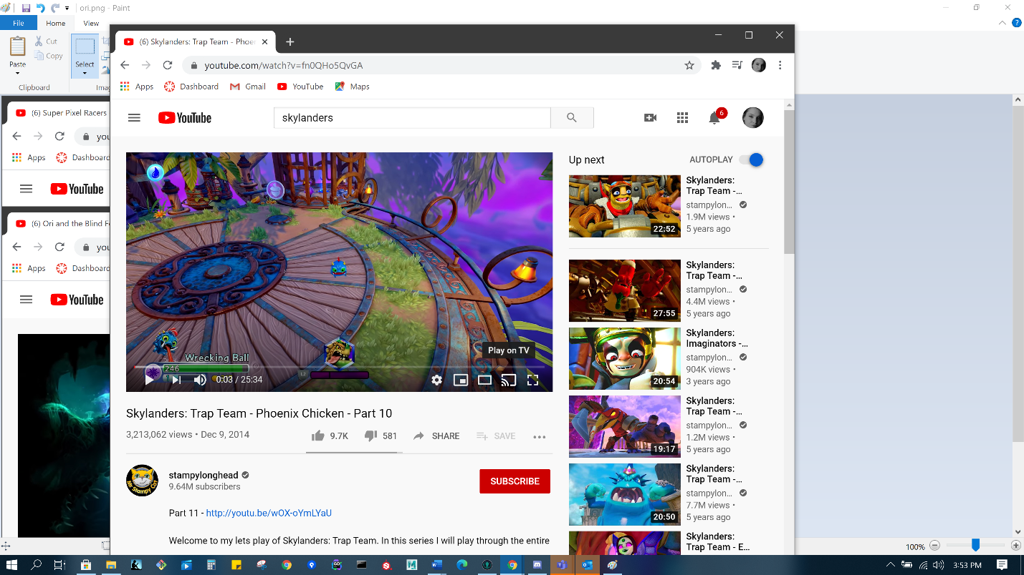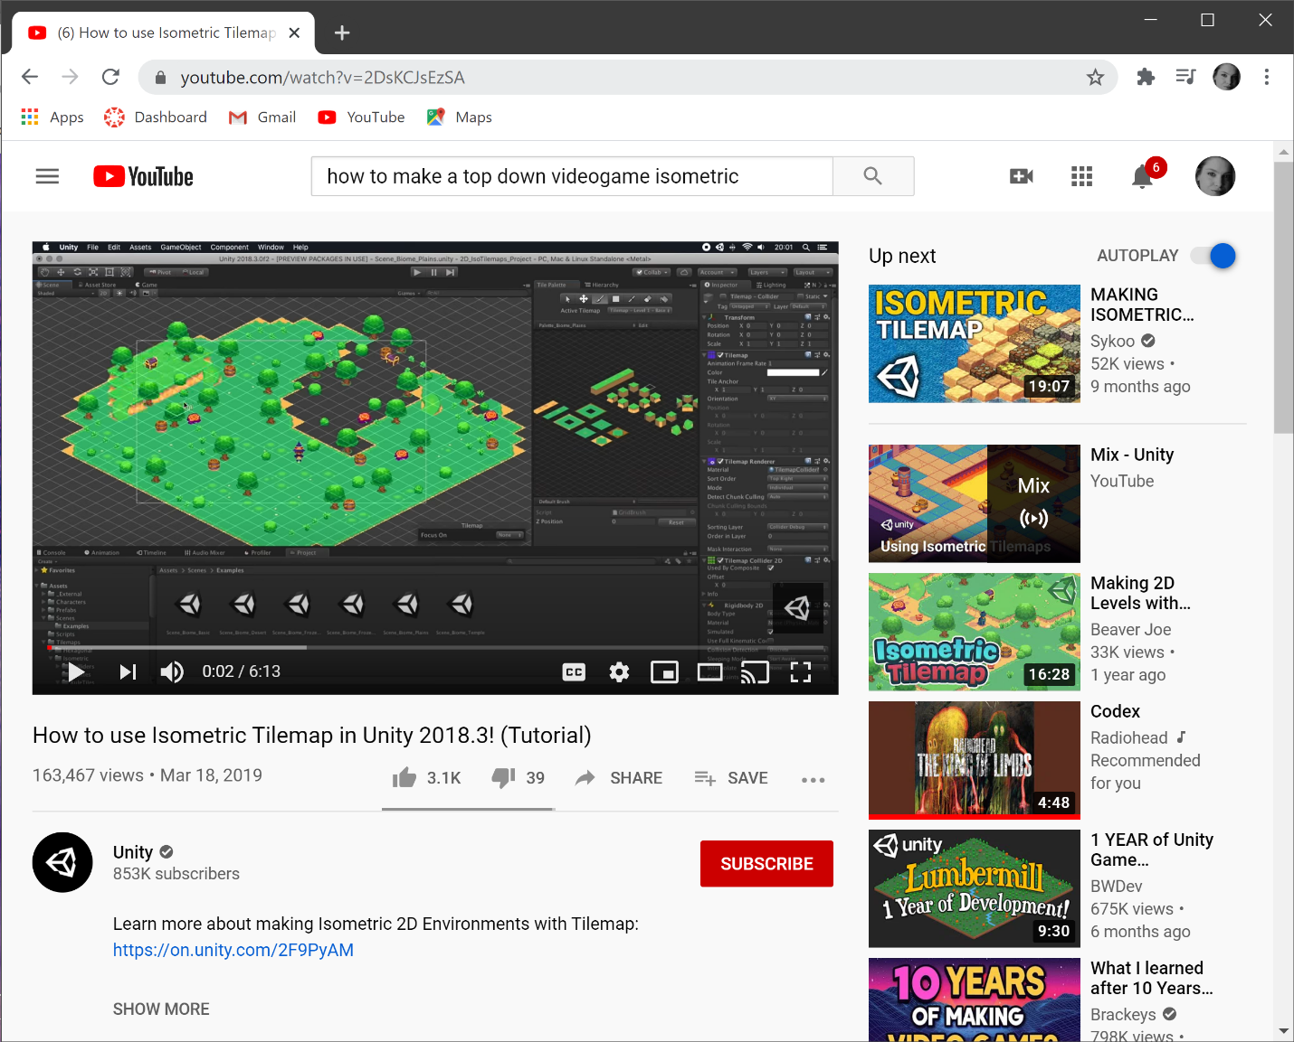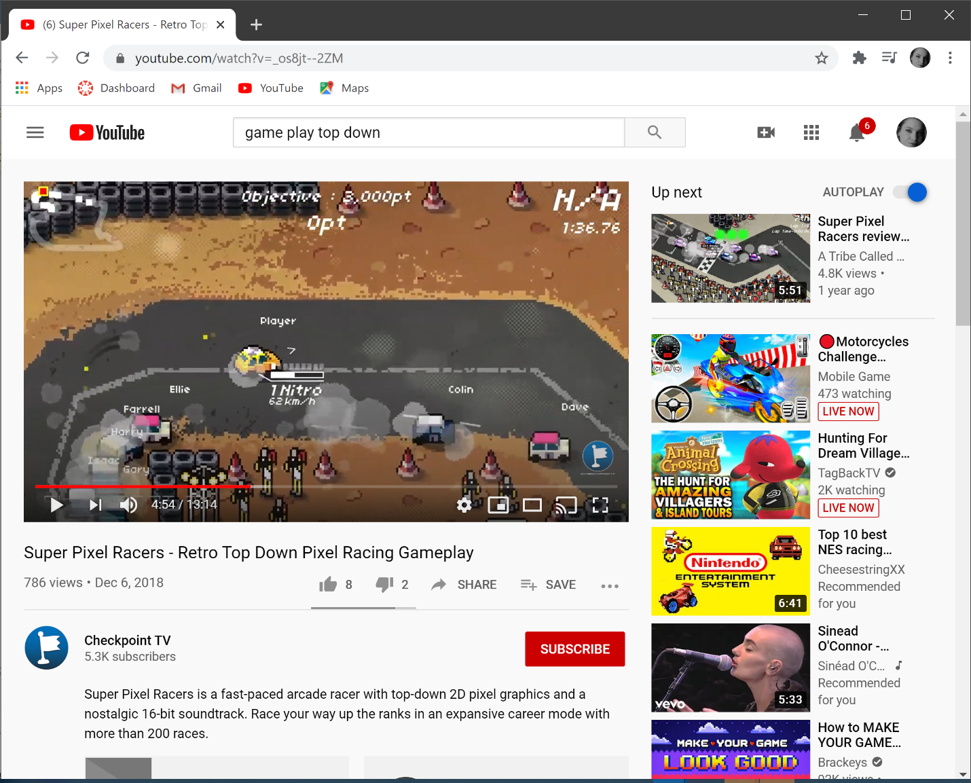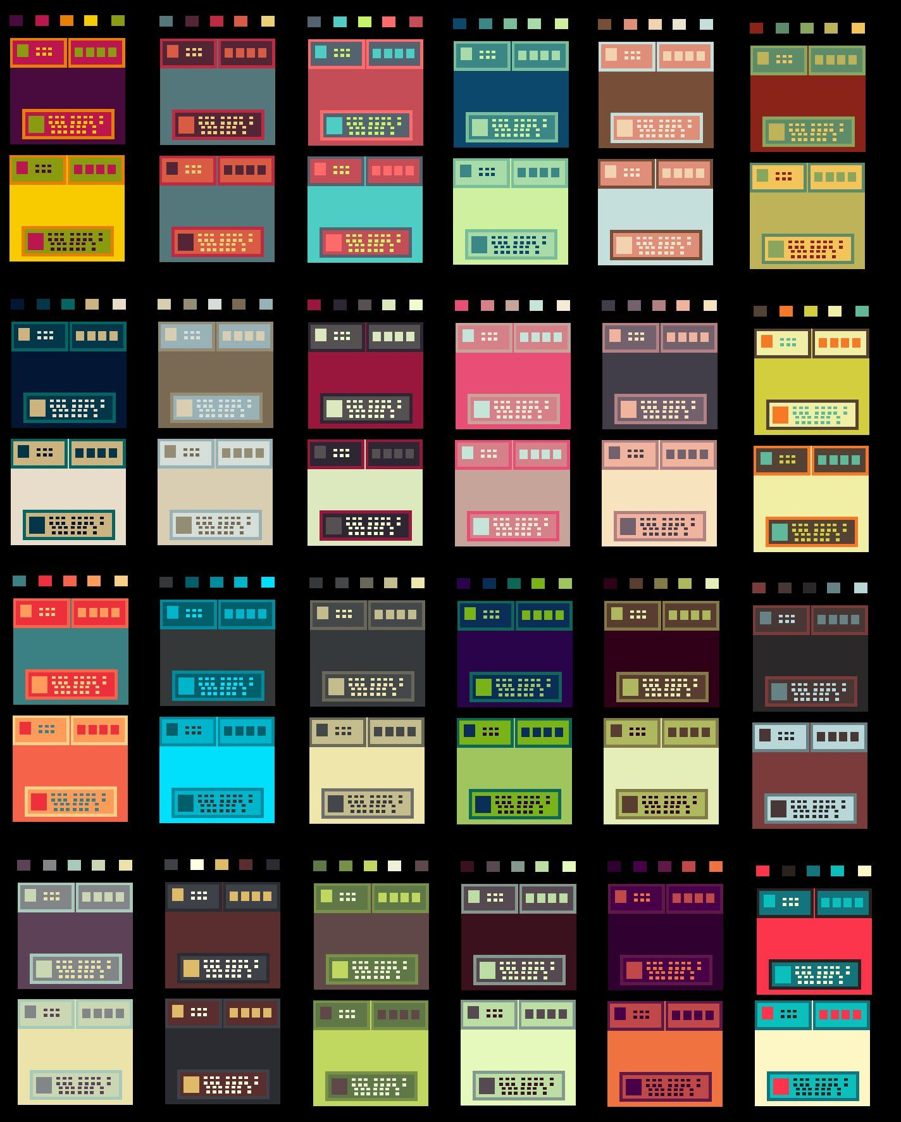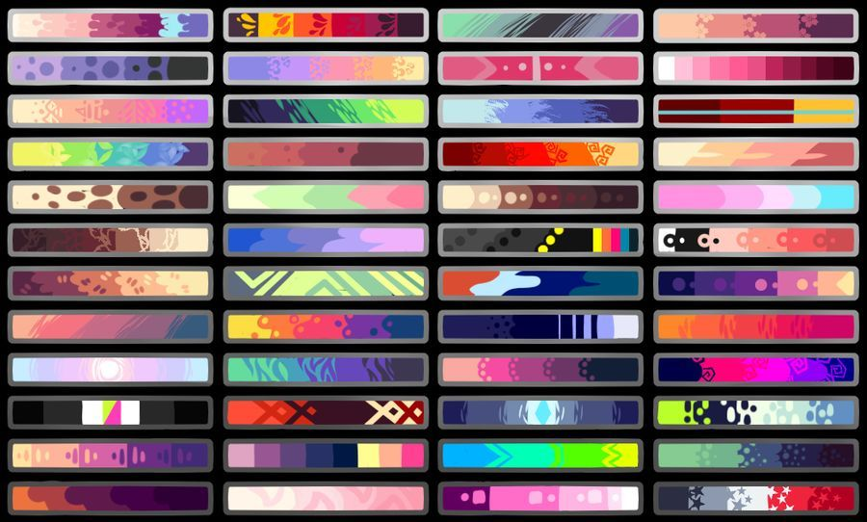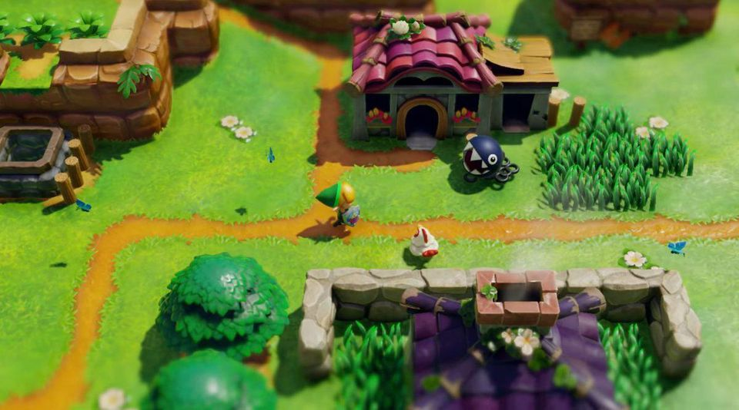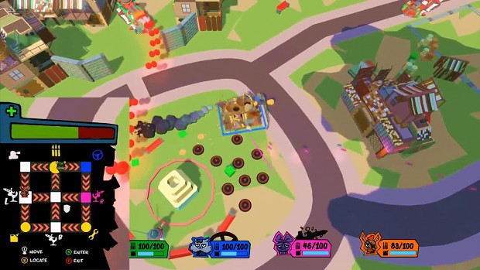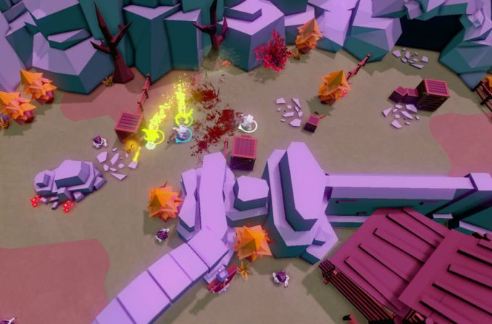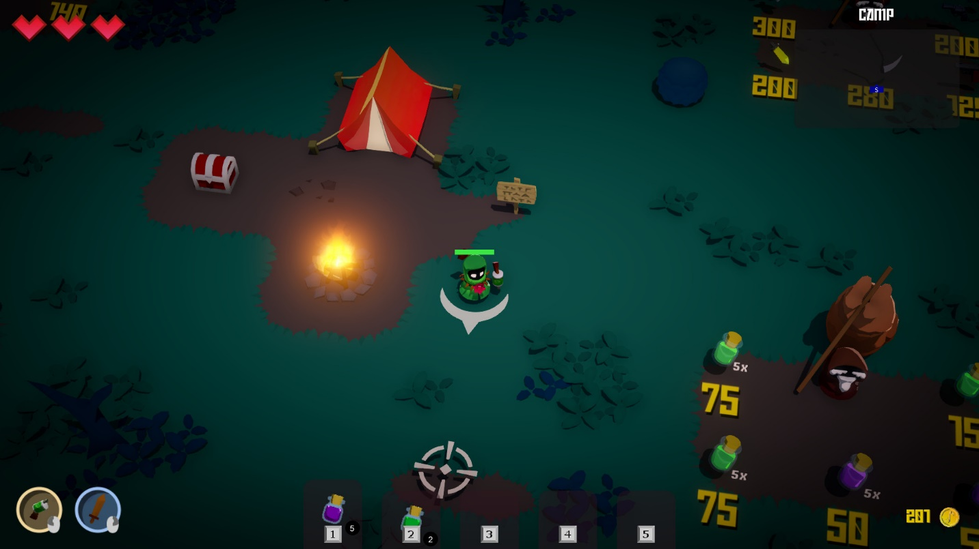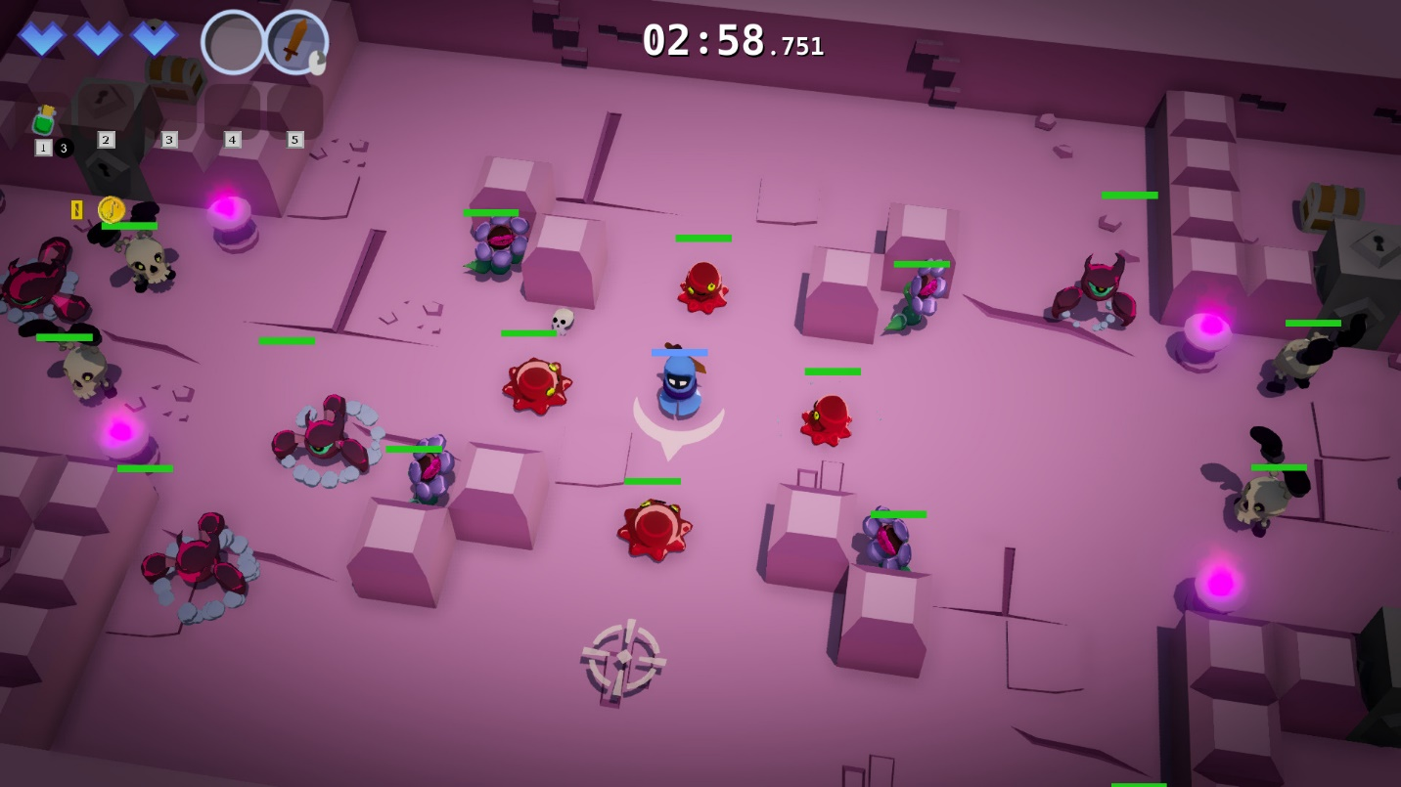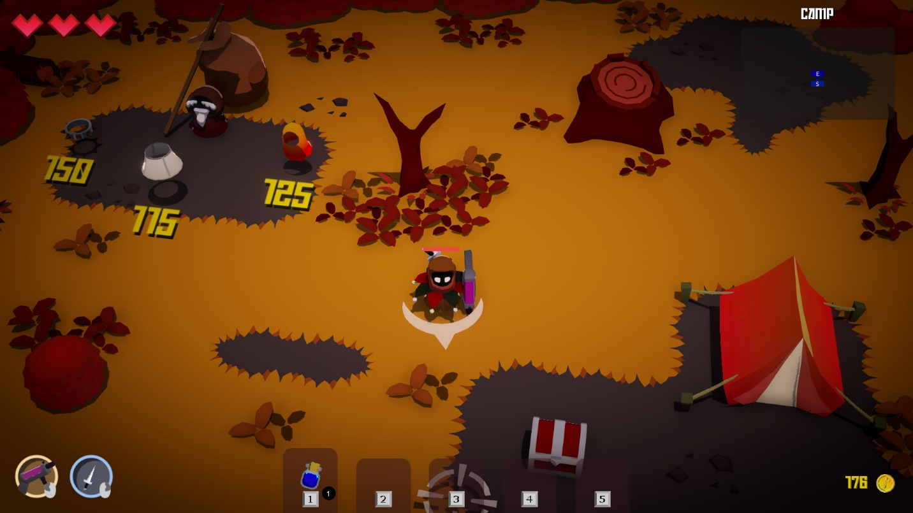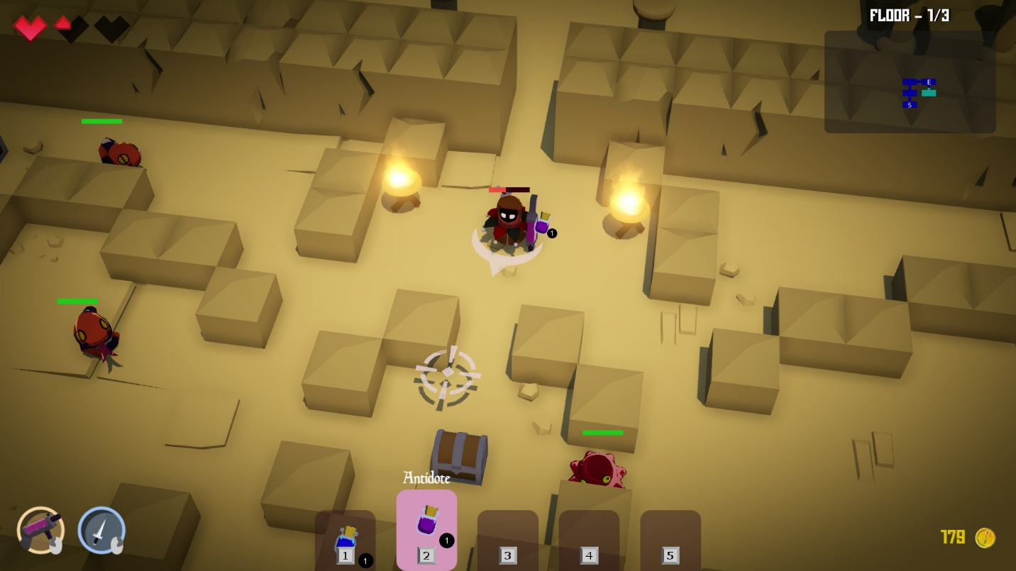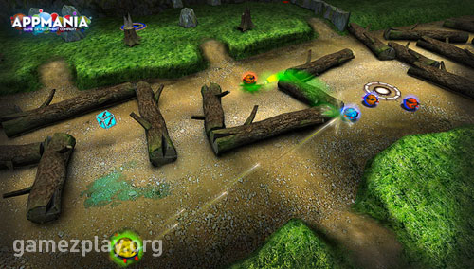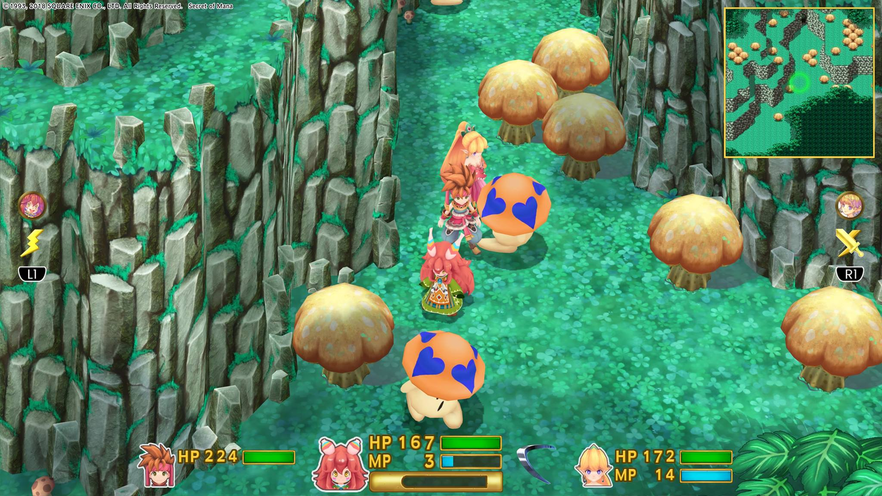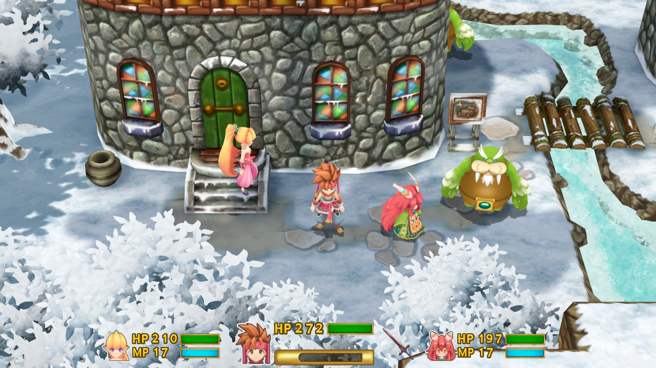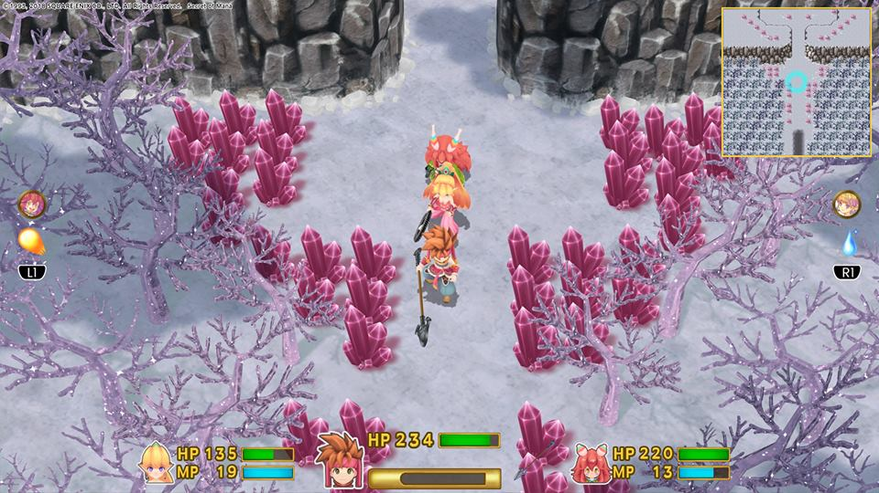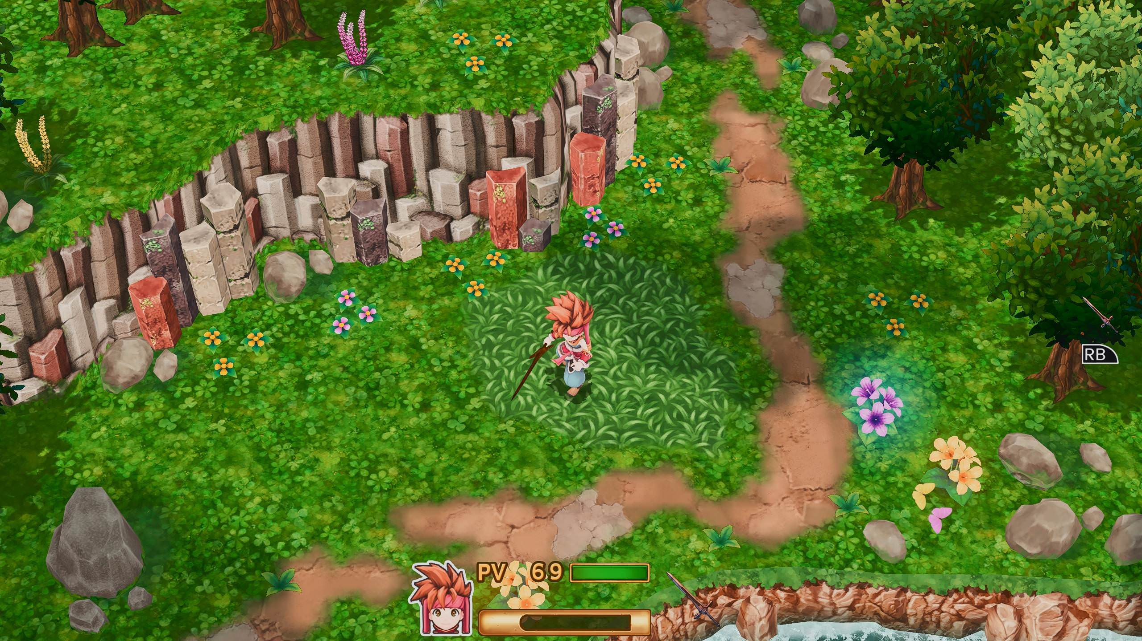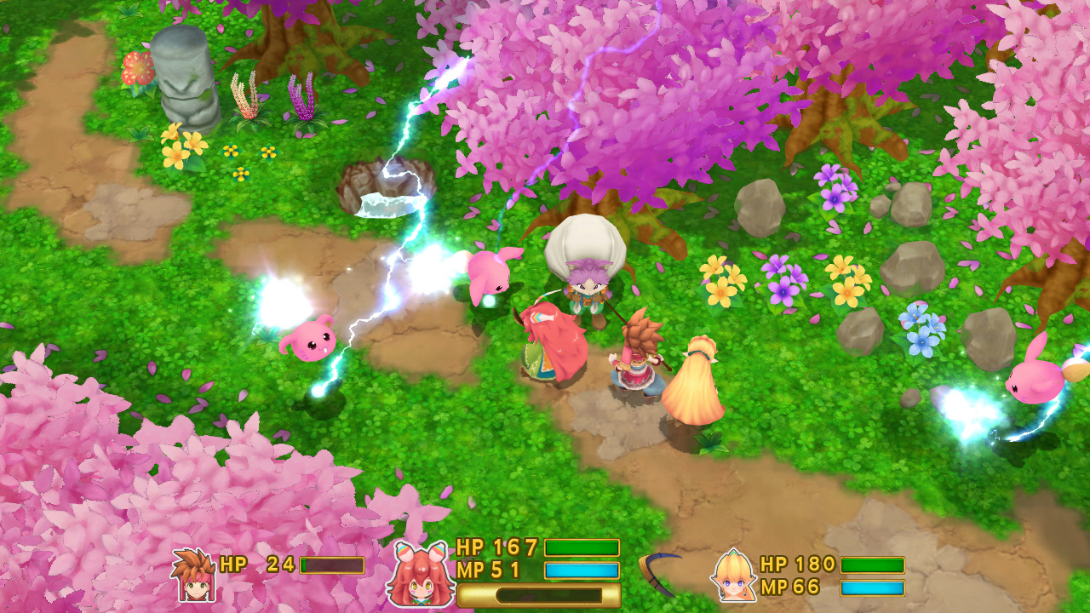etter guns and abilities

There are bosses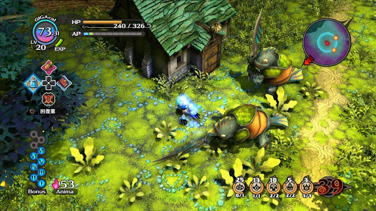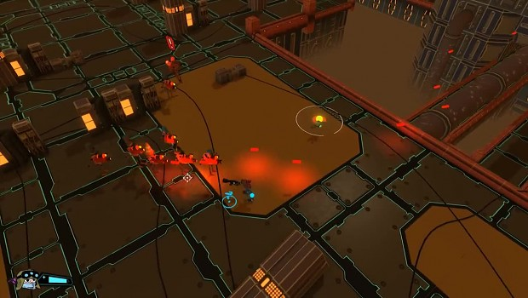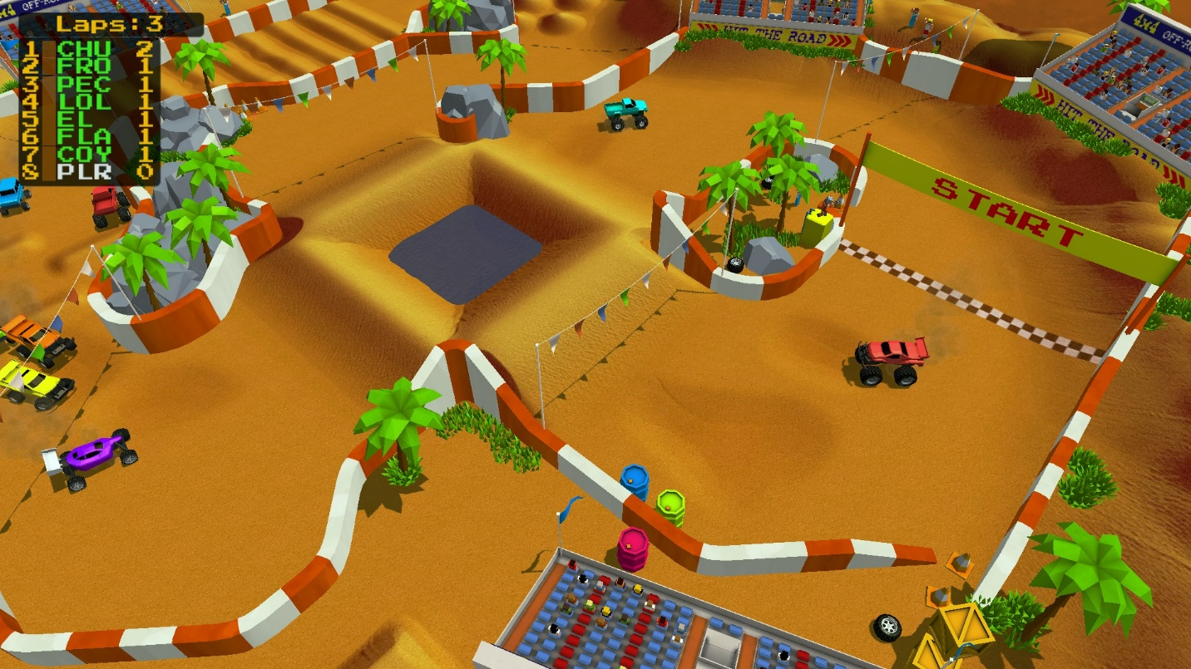

There will be puzzl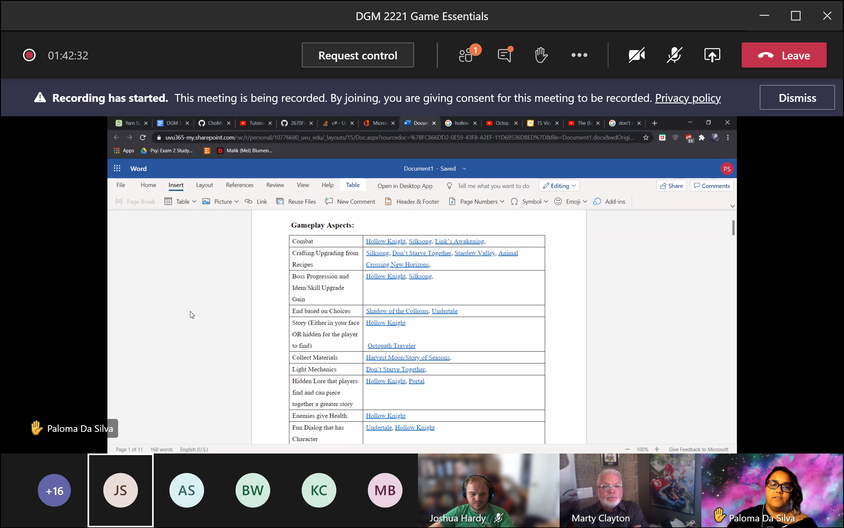es and battle and obstacle course.